Threat Prioritization
Candidate Slicing Procedure

Revision
Version 1
10/14/26 8:12 AM

Author
Charles Wilson

Abstract
This document describes the procedure used to perform the threat candidate slicing activity described in the AVCDL ^{[1]} Threat Prioritization Plan ^{[2]} secondary document.

Group / Owner
Security / Security Architect

Motivation
This document is motivated by the need to have formal processes in place regarding the disposition of cybersecurity-related threats in the context of the development of safety-critical, cyber-physical systems.
Note: Within the context of this document, the terms security and cybersecurity are used interchangeably. It is presumed that the term security is being used in reference to cybersecurity and not physical security.

License
This work was created by Torc Robotics and is licensed under the Creative Commons Attribution-Share Alike (CC BY-SA-4.0) License.
https://creativecommons.org/licenses/by/4.0/legalcode

Audience
The audience of this document is the cybersecurity practitioner who will be conducting the threat candidate slicing activity within the threat prioritization process.

Completeness of Output
Since threat candidate slicing is an as-is analysis, it is critical to ensure that the information gathered is as accurate and complete as possible. As with any cybersecurity assessment, it is not the place of the security SME to make assumptions on the part of engineering. All information should be sourced from and confirmed by the owner of the element under consideration.
When information is not available for either a given section of the template or parts thereof, this should be noted. Major omissions should be recorded in the cybersecurity risk register.

Disposition of Output
The output of this activity is used as input to either the risk domains consolidation activity or issue tracking system.
Once completed, the generated report should be managed in the organization’s document management system (DMS) as a document of record.

Entry Criteria
This document assumes that the reader understands the purpose of threat candidate ranking. Further, that the reader has read and understood the following AVCDL documents:
- Theat Prioritization Plan secondary document
- Threat Prioritization – Candidate Ranking Procedure ^{[3]} tertiary document
- Threat Prioritization – Candidate Risking Procedure ^{[4]} tertiary document

Prerequisites – Security SME

Qualifications
It is required that the security SME is both a qualified and trained security architect (shown above on title page as Owner) as defined by the NIST NCWF role SP-ARC-002 and detailed in the NCWF Roles - Security Architect section of the AVCDL Background Material elaboration document ^{[5]}.

Knowledge
It is required that the security SME understands the purpose of threat candidate slicing.

Background Information
It is required that the cybersecurity SME has read and understands the AVCDL documents listed above. Additionally, that the cybersecurity SME has taken training relevant to this activity.

Prerequisites – Input Materials
It is required that the security SME acquire any documentation relevant to the threat candidates under consideration necessary to complete the procedure.

Candidate Slicing Activity
The workflow diagram for the threat candidate slicing activity of the threat prioritization process is shown below.
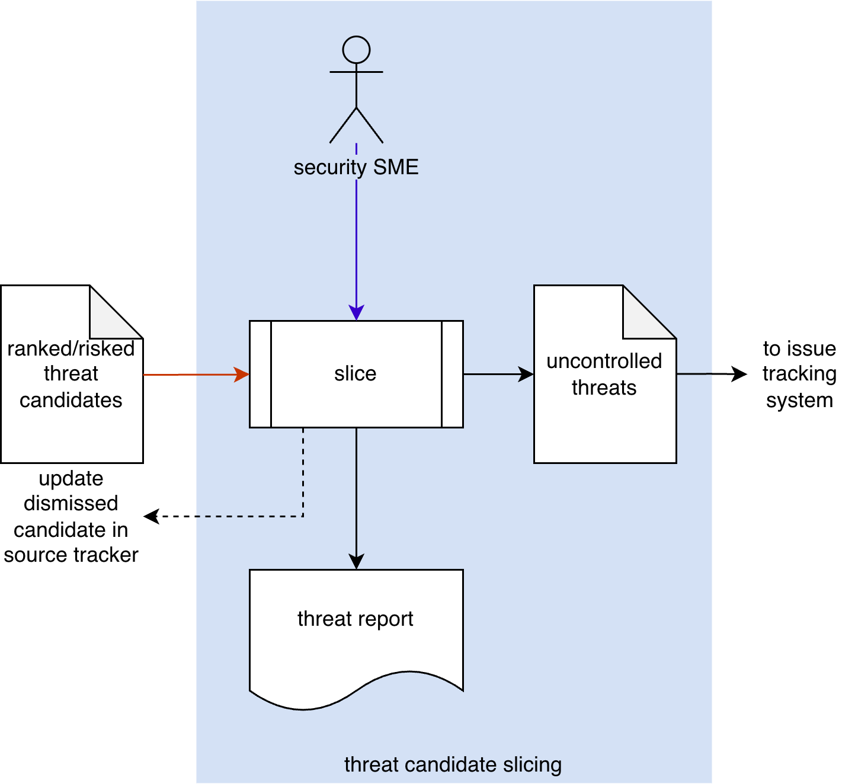
The security SME takes the ranked/risked threat candidates and conducts a slicing operation on them to determine which are uncontrolled, generating a list of uncontrolled threats. These are entered into the issue tracking system. All threat candidates deemed to be controlled are dismissed and their source tracker is updated. A threat report is produced.
Note: It is the responsibility of the standard issue management process to disposition uncontrolled threats by applying standard treatments (avoid, reduce, share, retain). This includes documenting the risk aspects of the issue and the reason for the disposition.
Note: If threat candidates are being considered by multiple risk domains, the uncontrolled threats should be sent to the risk domain consolidation activity.

Methodology
The recommended methodology for this activity is as follows:
- Select a risk appetite
- Plot the threat candidates
- Dismiss candidates determined to be controlled
- Prioritize the uncontrolled threats

Discussion
This section provides additional information to assist in performing this activity.

Risk Space - Continuous
In the ranking and risking activities, each of the threat candidates was assigned a likelihood and impact. The threat candidates can be plotted within a space with likelihood on one axis and impact on the other.
This can be visualized as follows:
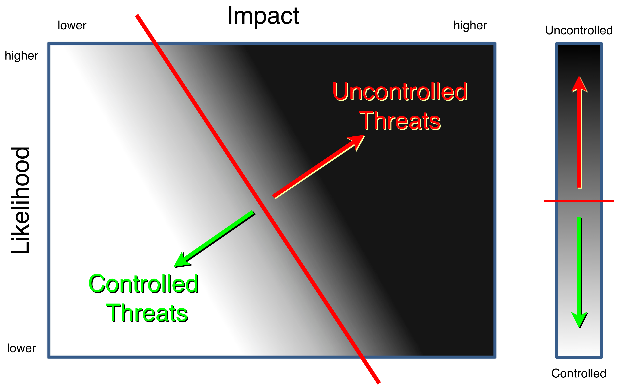
Note: Adapted from Postmarket Management of Cybersecurity in Medical Devices ^{[10]}.
The risk is shown as continuous greyscale.
The red line represents the organization’s risk appetite. This is used to slice (bisect) the space with those threat candidates above and to the right of the line being uncontrolled (requiring mitigation) and those below, controlled (not requiring mitigation).
The view on the right shows a simplified representation of this.

Risk Space - Quantized
When the likelihood and impact values are quantized it has the effect of reducing all threats into a lower resolution space.
This can be visualized as follows:
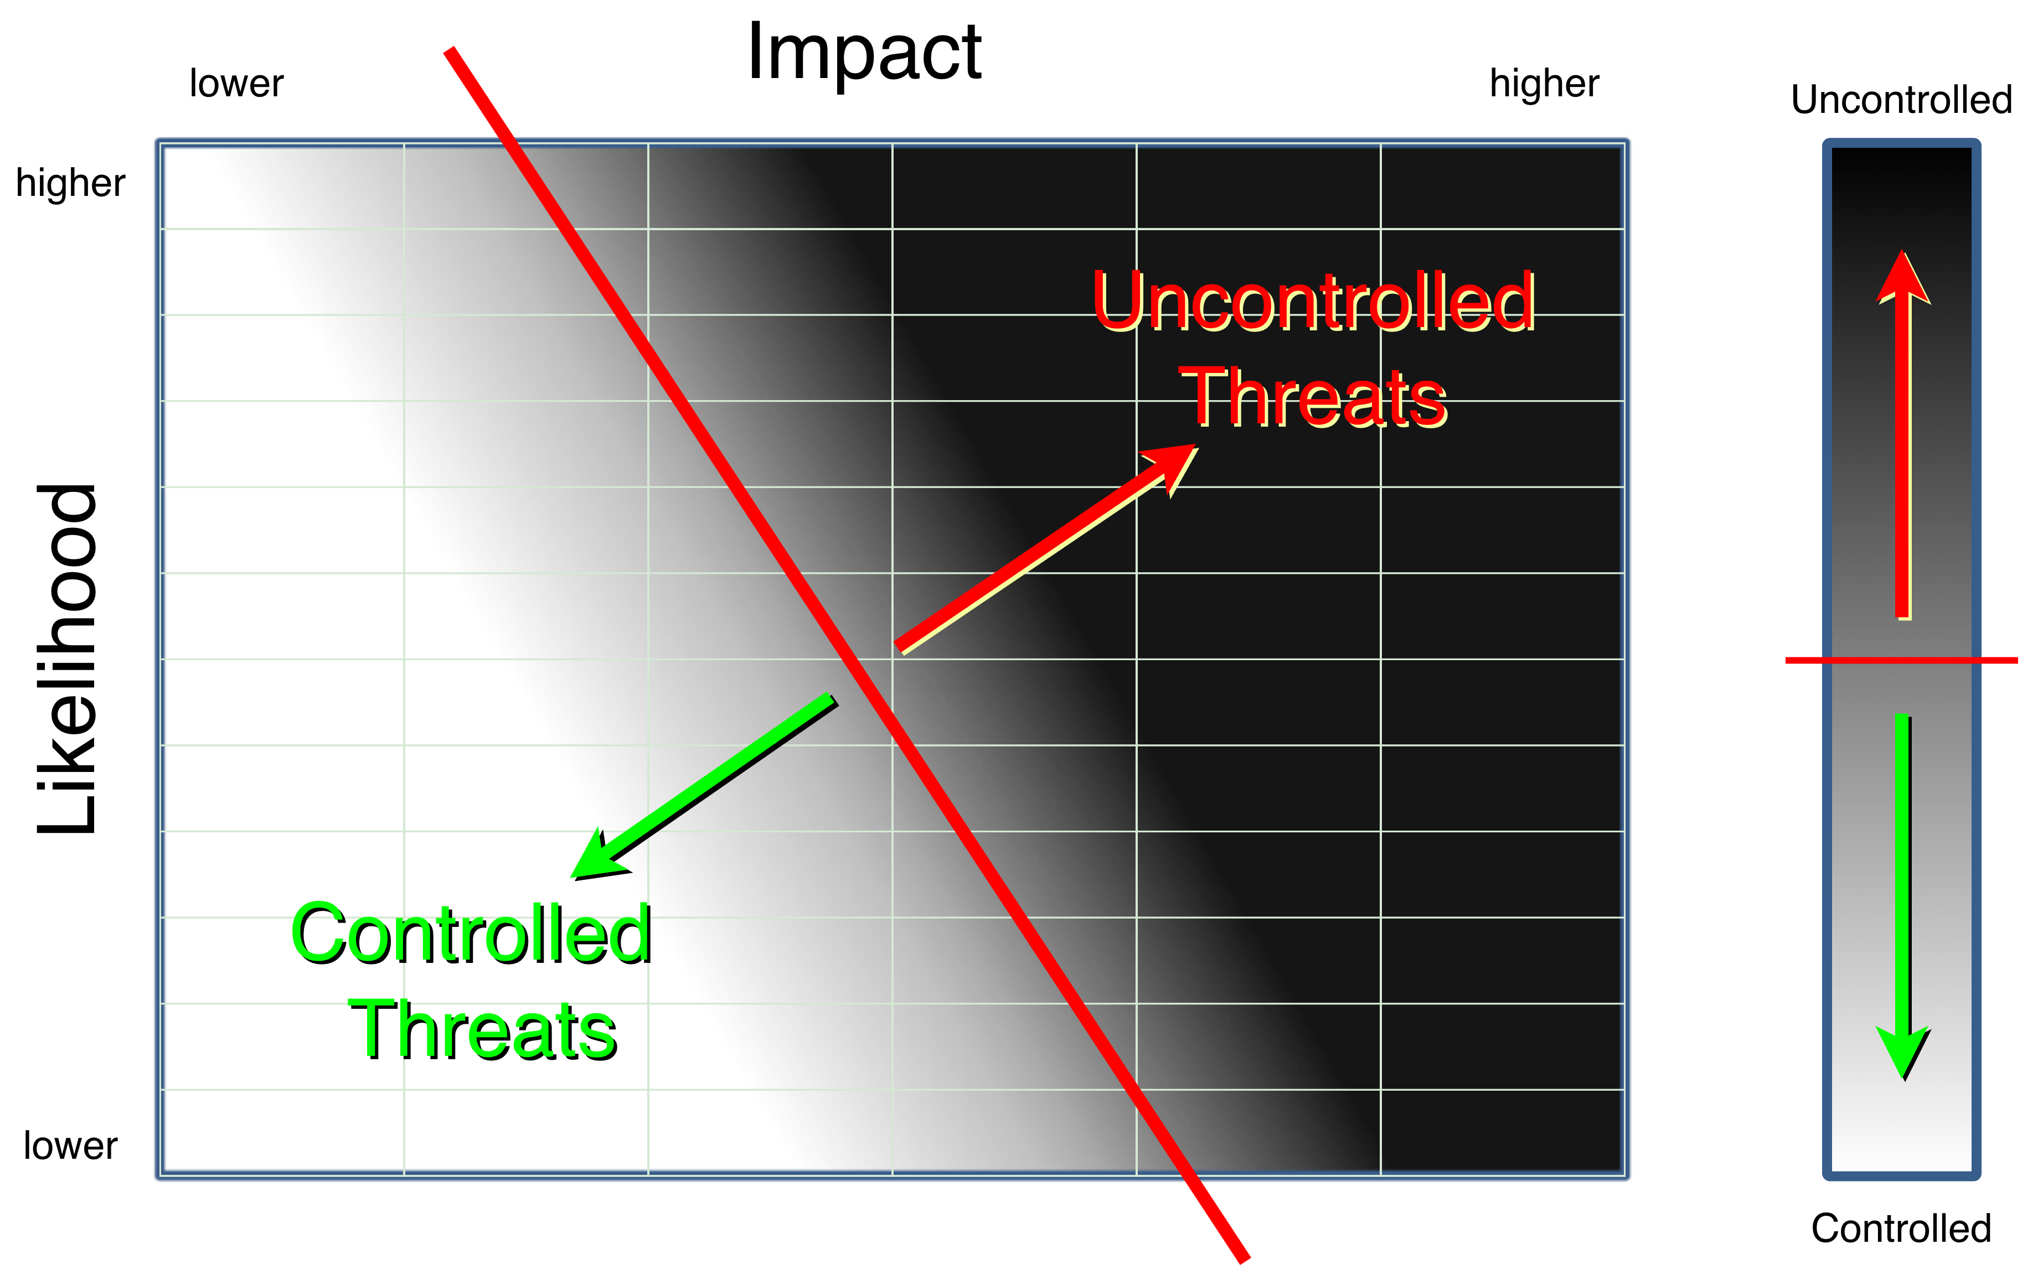
Since most rubrics either produce or work exclusively in a quantized space, this will be the most common representation of the risk space.
Note: The exact configuration of the space is determined by the quantization used by the likelihood and impact rubrics.

Risk Appetite - Continuous
When working in a continuous risk space, the risk appetite can be represented as a straight line bisecting the space.
This is illustrated in the following diagram.
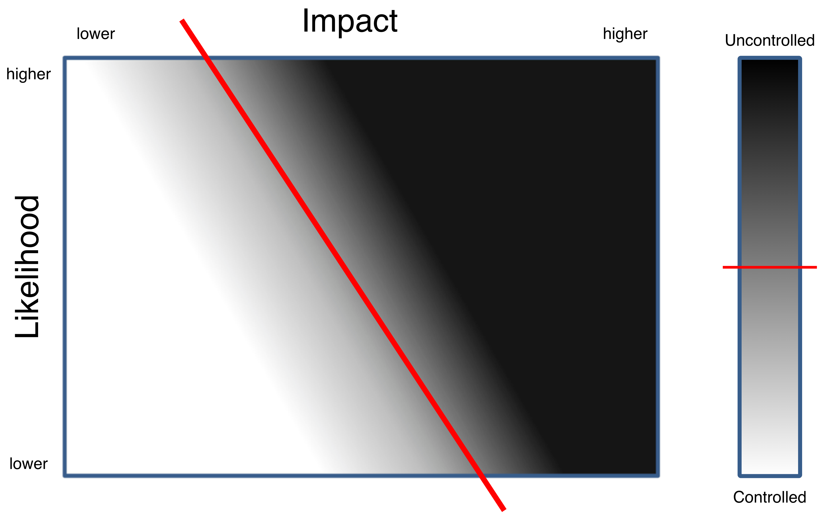
The difficulty with this approach is that the risk appetite line is somewhat arbitrary.
This approach does however lend itself to programmatic processing of the threat candidates.

Risk Appetite - Quantized
When working with a quantized space, the risk appetite cannot always be shown as a simple line.
Consider the following diagram showing the NIST SP 800-30 ^{[9]} risk determination (table I-2).
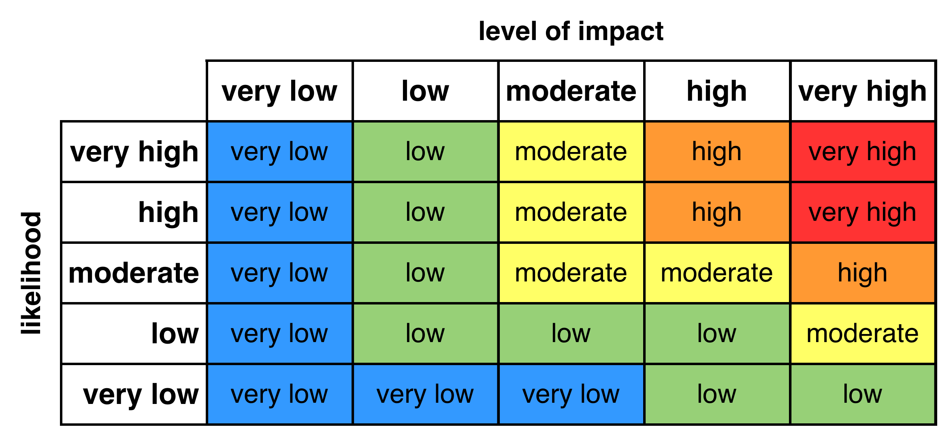
Based on the risk associated with the various combinations of likelihood and impact, it is clear that if an organization’s risk appetite has a cutoff other than high or very high that a straight line does not describe the appetite. In these cases, the risk appetite should simply be documented using a clear statement, such as “all threats with a risk value of high or very high are considered to be uncontrolled,” or by providing a diagram which highlights which risk values equate to an uncontrolled threat.
Most quantized spaces will not be a cleanly defined as NIST SP 800-30. For each combination of likelihood and impact rubric, a set of resultant risk rating will need to be determined and documented, prior to the slicing activity.

Threat Prioritization - Continuous
When prioritization of the uncontrolled threats is desired, and one is working within a continuous risk space, the magnitude of the normal from the risk appetite line to the location of the threat may be used to prioritize the uncontrolled threats.
This is illustrated in the following diagram.
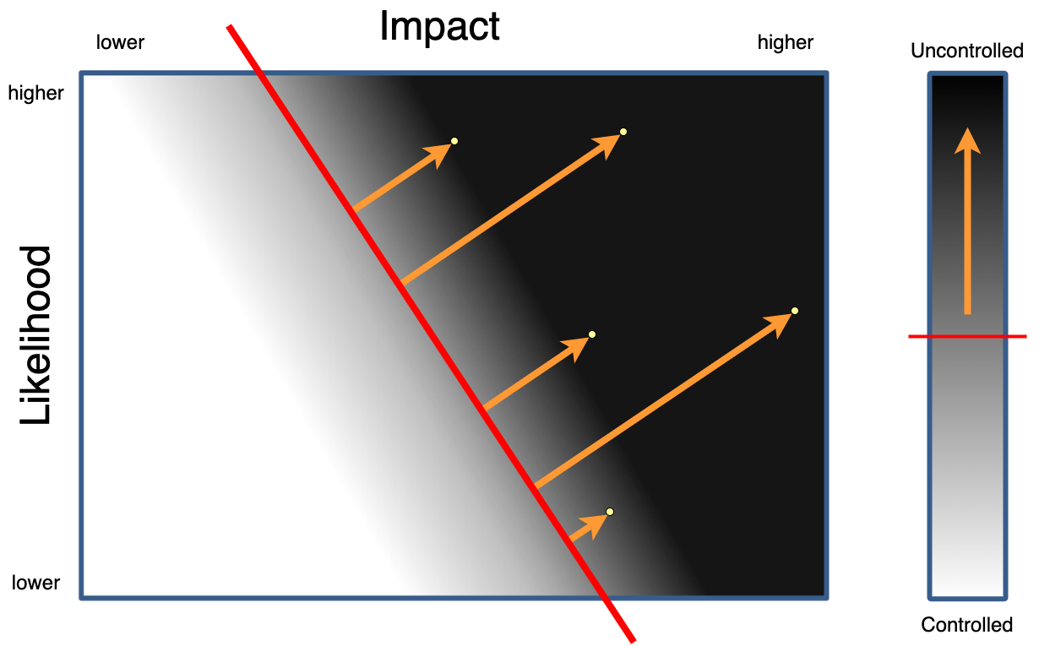
Higher priority threats have larger normal values.

Threat Prioritization - Quantized
When working within a quantized risk space, the product of the upper end values of the quantization bands for the likelihood and impact may be used to generate a priority ordering.
This is illustrated in the following diagram which uses a CVSS ^{[7]} likelihood quantization and an ISO/SAE 21434 ^{[8]} impact quantization.
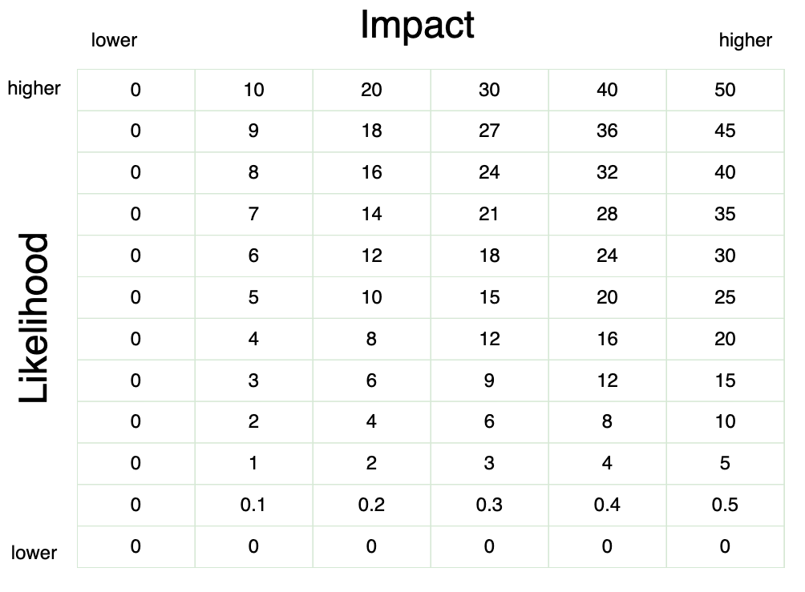
Since ISO/SAE 21434 does not specify the value ranges (bands) for the quantization, they have been mapped to align with the ones provided for CVSS.
Note: Because quantization reduces the resolution of the risk value, it will be less precise compared to the continuous approach. As a result, there is a greater likelihood that multiple threats will have the same priority.

Threat Candidate Slicing Template
(NIST SP 800-30 Rubric)
The threat candidate slicing may be documented using the AVCDL threat candidate slicing (SP 800-30) template Microsoft Excel workbook ^{[6]} when the NIST SP 800-30 rubric is used.
Note: Other forms of documentation are permissible so long as they provide the information laid out in this document.
Note: Because of the amount of tailoring required to create a template specific to an organization’s likelihood and impact rubrics (of which multiple may be used), only a template specific to NIST SP 800-30 is provided. This example should be sufficient for repurposing.
The workbook contains the following sheets:
- Cover sheet
- Revision history
- Reference documents
- Slicing
- 800-30 quantization
- Legend
- Scratchpad

Duplication of Rows in the Various Sheets
When there is the need to add rows to the various sheets of the workbook, be sure to duplicate an existing row. This is because validation checks and inter-sheet lookups may be attached to some of the cells which enables the use of drop-down lists and auto-population.

Cover Sheet
The cover sheet of the workbook is shown below:
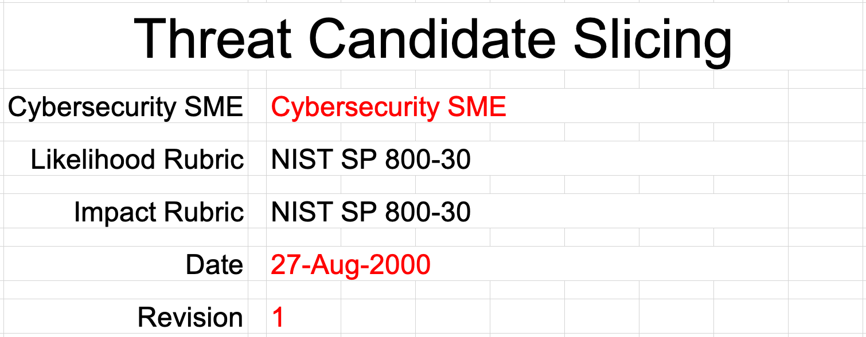
Fields to be completed are shown in red.

Cybersecurity SME
This is the cybersecurity subject matter expert creating the uncontrolled threats list.

Likelihood Rubric
This is the name of the rubric used to determine the threat candidate’s likelihood.

Impact Rubric
This is the name of the rubric used to determine the threat candidate’s impact.

Date
This is the date when the document was created or updated. The date should be updated whenever the document is updated.

Revision
This is the revision number of the document. The revision number is a monotonic and increasing integer, starting at 1. It should be incremented every time the document is updated.

Revision History
The revision history sheet of the workbook is shown below:
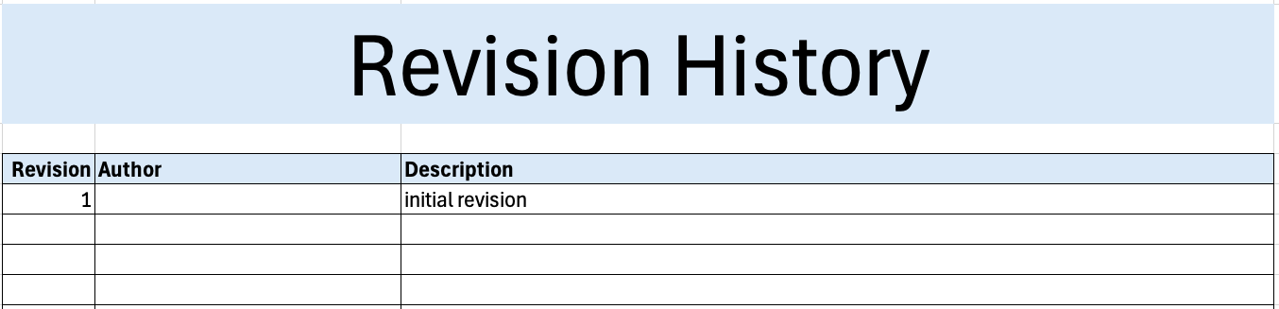

Revision
The revision corresponds to that listed on the cover sheet.

Author
The author corresponds to the cybersecurity SME listed on the cover sheet.

Description
This is a brief description of changes made to the workbook since it was last updated.

Reference Documents
Note: These references are those necessary for the creation of the uncontrolled threat list.
Note: References to ranking and risking inputs should be included.
The references sheet of the workbook is shown below:
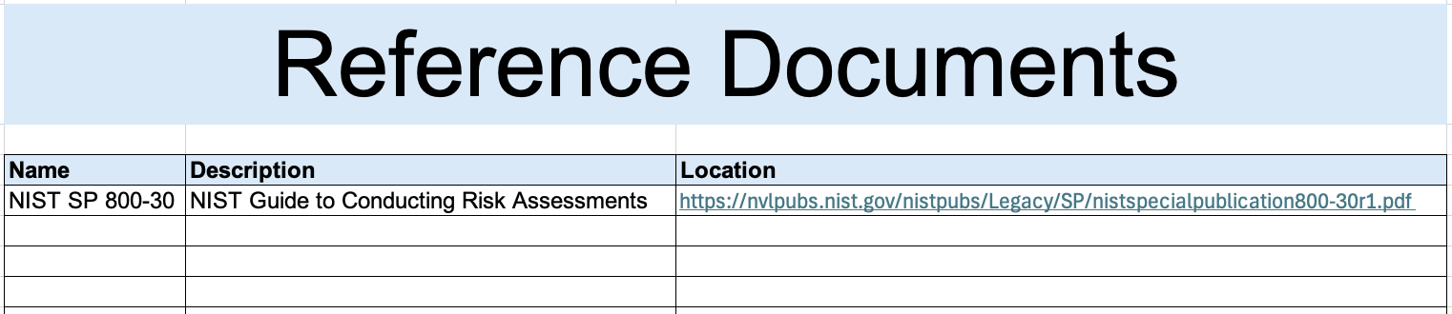

Name
This is the name of the document being referenced.

Description
This is a brief description of the document being referenced.
Note: In cases where the reference material is expressed in a form other than a document (for example, a web page), this should be noted.

Location
This is the location of the document being referenced. It may be a physical location or a URL.

Slicing
The slicing sheet of the workbook is shown below:
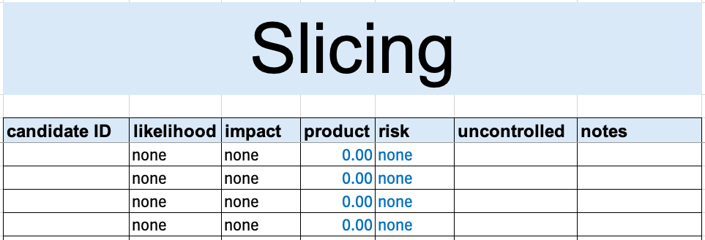

Candidate ID
This is the unique ID of the threat candidate.
Note: This value should be copied from the triage output providing input to this activity.

Likelihood
This is the threat candidate’s likelihood as determined in the threat ranking activity.
Note: This value should be copied from the threat candidate ranking activity output.

Impact
This is the threat candidate’s impact as determined in the threat risking activity.
Note: This value should be copied from the threat candidate risking activity output.

Product
This is the threat candidate risk determined as the product of the likelihood and impact values.
Note: This field is auto-populated.

Risk
This is the threat candidate’s quantized risk associated with the product value.
Note: This field is auto-populated.

Uncontrolled
This field indicates whether the threat candidate is determined to be uncontrolled based on the organization’s risk appetite.
Note: This field is drop-down.

Notes
This is a general notes field.

800-30 Quantization
This sheet provides translation between the likelihood / impact quantized representations and the associated values allowing their product to generate the desired quantized risk space values.
Note: This sheet (based on NIST SP 800-30) is complete as shown.
The 800-30 quantization sheet of the workbook is shown below:
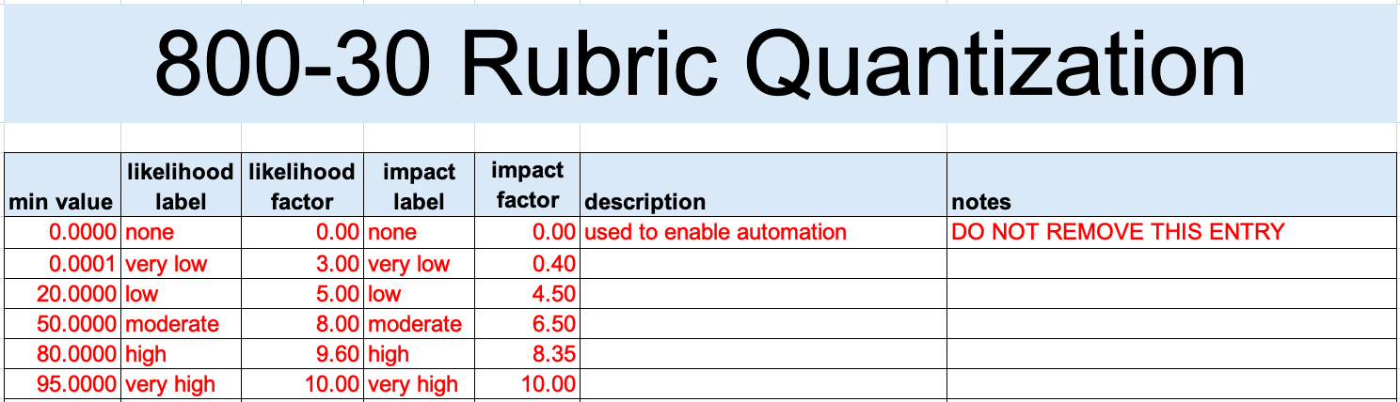
Note: A true zero (none) entry is included in order to support automation.

Min value
This is the minimum value of the quantization band.
Note: The second entry’s value is set to be slightly greater than the ‘none’ band.
Note: The values of this field are assigned in order to generate the quantized values specified in NIST SP 800-30 table I-2.

Likelihood label
This is the name of the likelihood quantization band.
Note: This column is used to populate likelihood fields on the slicing sheet. It is used for both drop-down lists and computed fields.

Likelihood factor
This value is used to generate the risk value when multiplied by the impact factor.
Note: The values of this field are assigned in order to generate risk values specified in NIST SP 800-30 table G-5.

Impact label
This is the name of the impact quantization band.
Note: This column is used to populate impact fields on the slicing sheet. It is used for both drop-down lists and computed fields.

Impact factor
This value is used to generate the risk value when multiplied by the likelihood factor.
Note: The values of this field are assigned in order to generate risk values specified in NIST SP 800-30 table H-3.

Description
This is the description of the quantization band.

Notes
This is a general notes field.

Legend
This sheet provides fixed values for various drop-down fields.
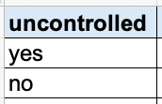

uncontrolled
This is used to populate the uncontrolled field of the slicing sheet.

Scratchpad
This sheet illustrates how the likelihood and impact rubric quantizations can be used to generate an arbitrary risk value.
Note: This sheet is based on NIST SP 800-30.
The first two tables of the 800-30 quantization sheet of the workbook are shown below:
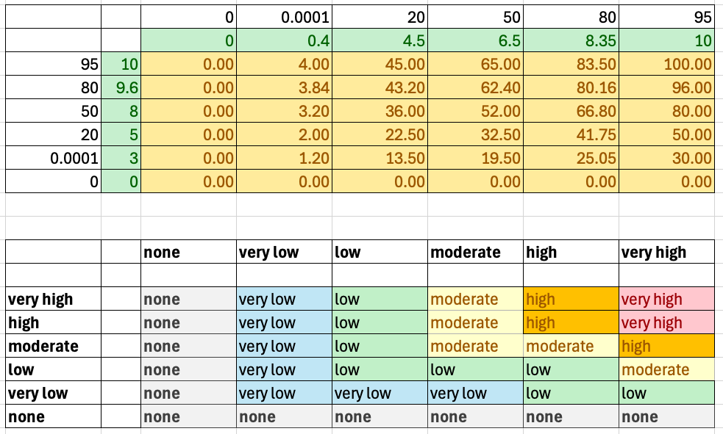
Note: A true zero (none) entry is included in order to support automation.

Elaboration
In these tables, as with other risk diagrams, the likelihood is shown on the left and impact across the top. These values are the minimums for the quantization ranges.
The green bands represent the factor values which when multiplied together generate the field of the table. These are the raw risk values.
Note: The raw risk values can be used to prioritize the uncontrolled threats.
The bottom table shows the raw risk values mapped to the quantization labels.
Note: The cell colors have been applied manually to allow visual inspection of the table to ensure that the factors are producing the desired result.
Note: The values of this field are assigned in order to generate the qualitative values specified in NIST SP 800-30 table I-2.
Note: The values for the factors (top table in green) are determined iteratively.
The following table on the sheet is used to assist in verifying specific combinations of likelihood and impact.
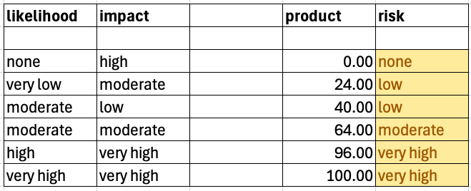
Note: The likelihood and impact fields are drop-downs, whereas the product and risk fields are computed.

Exit Criteria
This procedure is considered complete once the uncontrolled threats list has been generated and the individual threats are entered into the issue tracking system.
Additionally, the threat report should be entered into the DMS.

References
- AVCDL (AVCDL primary document)
- Theat Prioritization Plan (AVCDL secondary document)
- Threat Prioritization – Threat Candidate Ranking Procedure
(AVCDL tertiary document)
- Threat Prioritization – Threat Candidate Risking Procedure
(AVCDL tertiary document)
- AVCDL Background Material (AVCDL elaboration document)
- AVCDL threat candidate slicing (SP 800-30) template (AVCDL template)
- Common Vulnerability Scoring System
https://www.first.org/cvss/
- ISO/SAE 21434:2021 Road vehicles – Cybersecurity engineering
https://www.iso.org/standard/70918.html
- NIST SP 800-30 r1 – Guide to Conducting Risk Assessments
http://dx.doi.org/10.6028/NIST.SP.800-30r1
- Postmarket Management of Cybersecurity in Medical Devices
https://www.fda.gov/regulatory-information/search-fda-guidancedocuments/postmarket-management-cybersecurity-medical-devices

